Grand Lodge A.F. & A.M. of Canada
in the Province of Ontario

College of Freemasonry

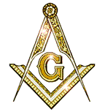

Preparatory Course for Worshipful Masters

Course Enrolment Form

Date:

Name:

Address:

City: Postal Code:

Lodge:

District:

Telephone No:

E-Mail: Please print clearly

Masonic Rank:

Signature:

Please fully complete the registration form, together with a cheque payable to “Preparatory Course for Worshipful Masters in the amount of $50.00 and mail to:

Mr. Gordon Hendrie
4192 Longmoor Drive, Unit 9
Burlington, Ontario
L7L 5E3
gordon.hendrie@sympatico.ca Revised June 2, 2011

